EXPERIMENT 6

DML COMMANDS (COLLEGE SCHEMA)

Aim:

Insert 5 instances into the tables created in experiment 6.

Display the tables.

Add attribute course to student table then insert values.

Use update to set course for students.

Delete an attribute.

**QUERIES:**

Insert 5 instances into the tables created in experiment 6.

Display the tables.

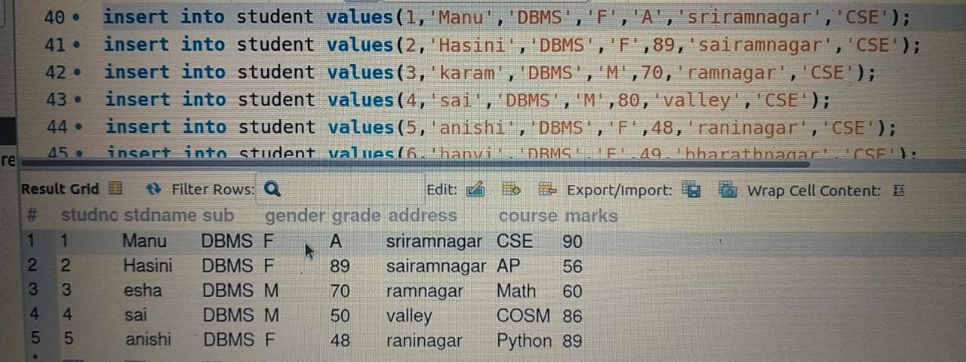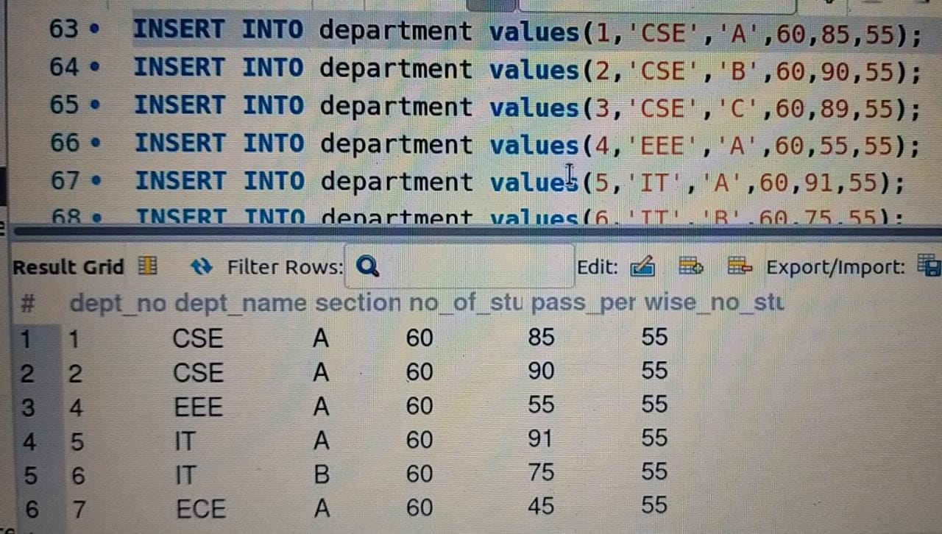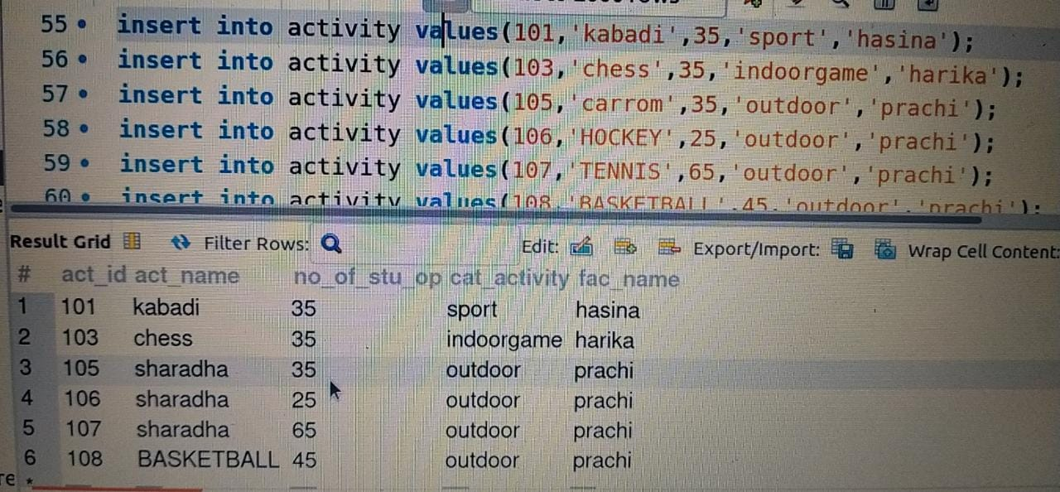

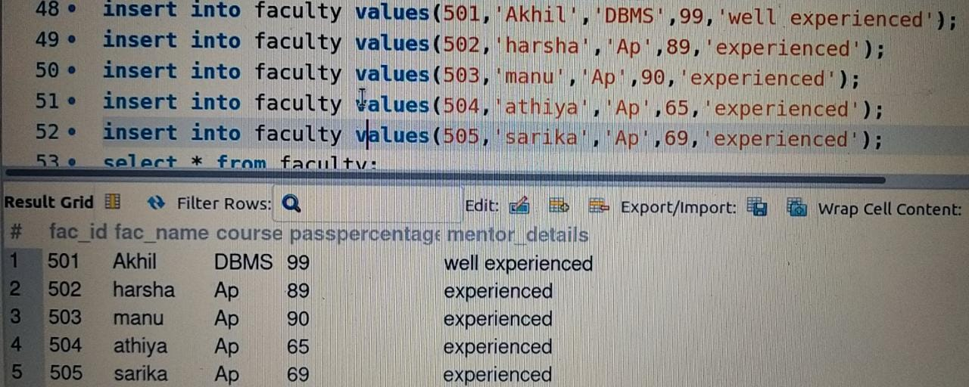

Add attribute course to student table then insert values.



Use update to set course for students.

Delete an attribute.

